

## SESTICKET – INSTALLATION CLIENT GUIDE

**SUMMARY**

1. DOCUMENT HISTORY 2

2. ABOUT THE INSTALLATION 3

3. PRE REQUISITES 3

4. CONFIGURING THE SESTICKET 3

5. KNOWLEDGE BASE (ISSUES, TIPS, ETC) 4

# DOCUMENT HISTORY

|  |  |  |  |
| --- | --- | --- | --- |
| **VERSION** | **DESCRIPTION** | **AUTHOR** | **UPDATE DATE** |
| 1.0 | Document Creation | Fernando Melo | 19/JUL/2017 |
|  |  |  |  |
|  |  |  |  |
|  |  |  |  |
|  |  |  |  |
|  |  |  |  |
|  |  |  |  |

# ABOUT THE INSTALLATION

This document contains all procedures for installation and configuration of SESTICKET on the user computer.

# PRE REQUISITES

* The user should have a SESTicket account (check it with Administrator).
* The computer should have installed the Microsoft Office 2013.
* The following components must be installed on the computer:

Obs.: The installation files are storage in \\colapp07\SESTicket\Release\components

Check the Windows architecture (x86 or x64)

|  |  |
| --- | --- |
| **Component** | **Executable** |
| Microsoft .NET Framework 4.5.1 | NDP451-KB2858728-x86-x64-AllOS-ENU.exe |
| Microsoft Access database engine 2010 | AccessDatabaseEngine.exe |
| Microsoft SQL Server 2008 R2 Native Client | sqlncli_amd64.msi (x64)  sqlncli_x86.msi (x86) |
| Microsoft System CLR Types for SQL Server | SQLSysClrTypes.msi (x64)  SQLSysClrTypesx86.msi (x86) |
| Microsoft Report Viewer 2012 | ReportViewer.msi |

* Check if the user is reaching on the path: \\colapp07\SESTicket

# CONFIGURING THE SESTICKET

1. Check if the computer is connected on Superior network
2. Get the most recently version file of SESTicket through path:

\\colapp07\SESTicket\Release

Ex.: The current used on this document is SESTicket_v4.0.5.zip

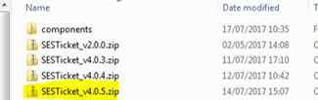

1. Uncompress the file on Hard Disk “c:\”. At the end, check if the path used by SESTicket as the same of the directory structure below:

C:\SESTicket

\app

\data

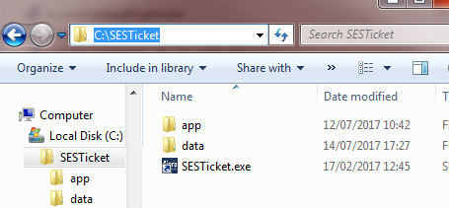

1. Copy the shortcut “SESTicket.exe” located on “C:\SESTicket” to user´s desktop
2. **The first user login should be using the SESTicket.** Open the application using the shortcut and ask to user input the user and password (the same used on the login process on Windows). At this time, the application will be configured and the user can be open the main screen.

# KNOWLEDGE BASE (ISSUES, TIPS, ETC)

|  |  |
| --- | --- |
| The user cannot connect on the application | * Check if the computer is connect on Superior network * Check if the user has an account on the system (with system administrator) |
| The menu options on the system is disabled/not available | * Check the user right with the system administrator |
| The reports are not working (with error message)  The report does not exporting to Excel, pdf, Etc. | * Check if the Microsoft Report Viewer 2012 component is installed correctly. If yes, uninstalled and re-installed this component again and check if the issues are fixed. |